Creating Your Own Exam
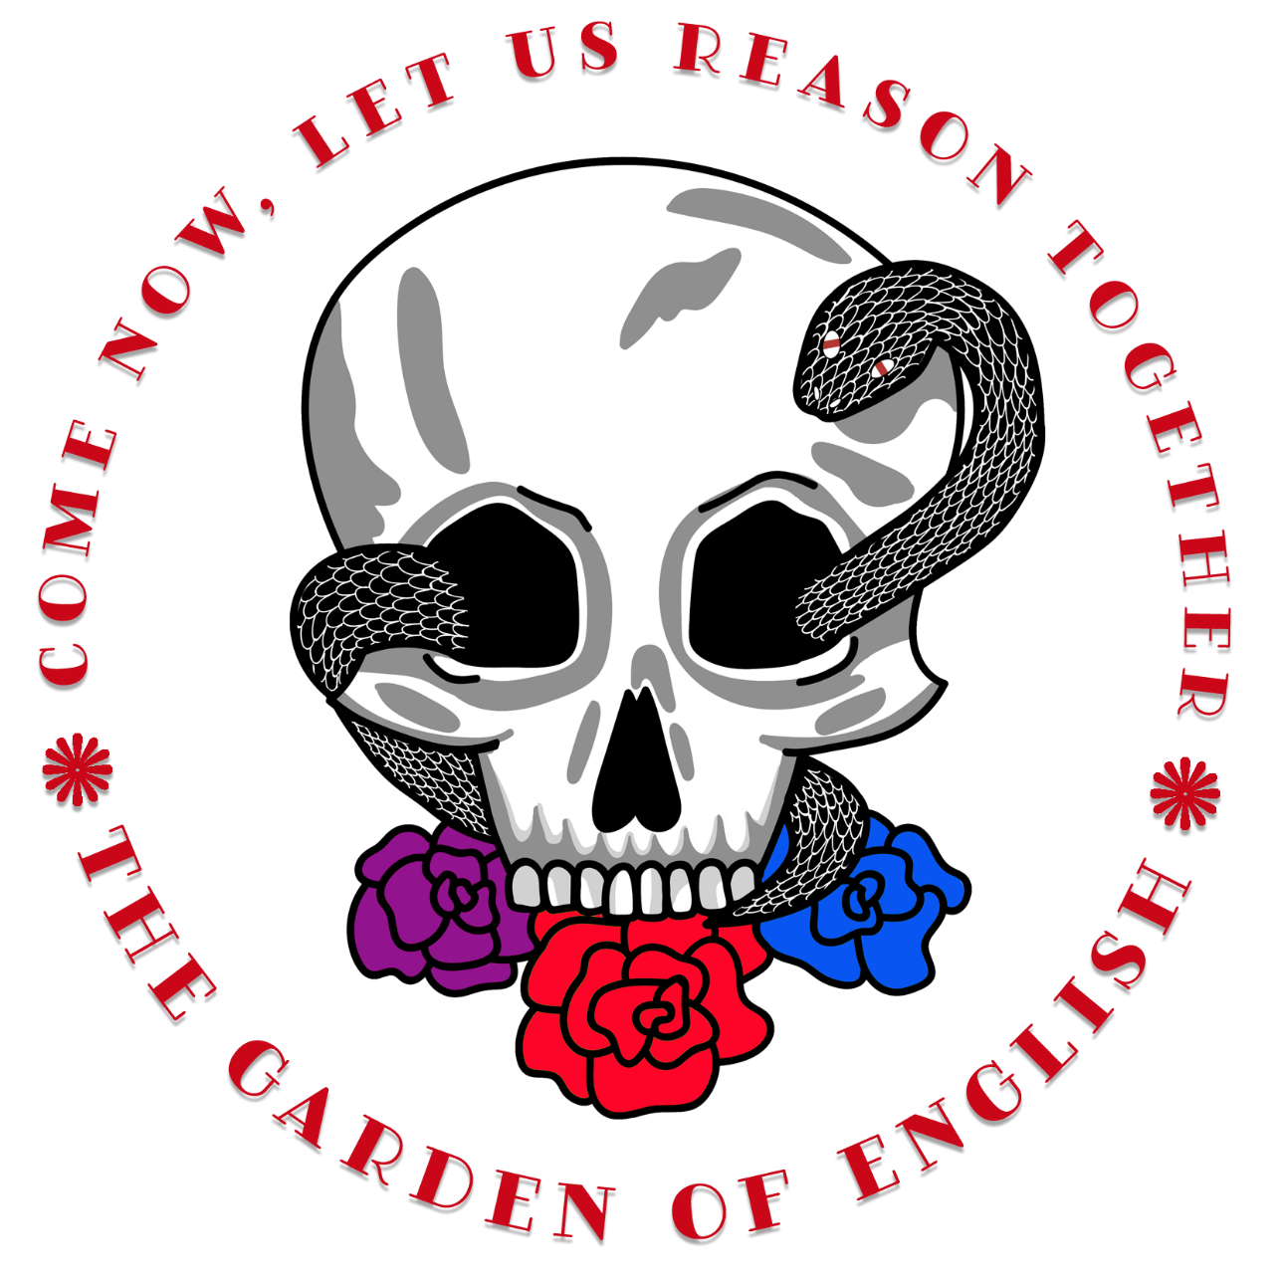
Timm Freitas
The Garden of English
GardenofEnglishResources@gmail.com

Overview
In order to help my students review for their AP® English Language exam, I assign a create-your-own-exam project. In order to complete this, each student has to create a synthesis prompt—for which they will produce a 7-page paper (citing all sources)—rhetorical analysis prompt, argument prompt, and rhetorical analysis multiple-choice selection that includes 5 multiple-choice questions. In this packet, you will have a properly formatted (for Microsoft Word) template that will help students as they create their own assignments.
The Protocol
The students research a topic of their choice, create the prompt, excerpt their own sources, and then use these sources for the rest of their create-your-own-exam. The rhetorical analysis prompts that students create are based on one of the excerpted sources from the synthesis packet. The argument prompt must draw a quote from at least source not used as the rhetorical analysis passage, and the multiple-choice section will be based on reading a source not related to the Q2 or Q3 prompt already created. The templates in this document do rely heavily on the new stable prompt wording found in the AP® English Language and Composition Course and Exam Description (CED).
Writing Multiple Choice
Writing multiple choice can be hard; however, I hope that the organized stems found here can help you and your students work to produce their own questions and think critically about different genres of non-fiction readings.
On the actual exam, there seldom multiple-choice questions that have more than one lead distractor: the answer meant to lead individuals away from the actual, correct answer. But, you’ll notice in my multiple-choice answers template below, I require whoever is producing answers to include all three types of lead distractors for the sake of consistently familiarizing one’s self with what to look for in wrong answers. Such practice should lead to greater success in understanding what to look for when it comes to working with an actual AP® exam.
The types of lead distractors I’ve included are only anecdotal in nature. Thus, I have noticed patterns of lead distractors over my many years of reading multiple-choice questions for Lit and Lang exams. So, there may be other qualities or types that I have not noticed, and what’s listed below are not official College Board criteria; however, I trust you will find these observations enriching and enlightening.
When you create a multiple choice question, you want to follow a few steps: First, you want to locate the unit within which you want to test a skill. Following this, you’ll want to identify the Big Idea and Enduring Understanding that you are trying to test. You’ll also want to locate the specific skill (whether reading or writing) that relates to the Big Idea and Enduring Understanding category, and finally you’ll want to identify the exact piece of Essential Knowledge you want your question to consider. Once you have these in mind, you can use the multiple-choice stems document to begin generating your question. Your question should then follow the format presented below:
- Multiple Choice Stem.
  - the answer is entirely wrong
  - the answer has one piece of truth, but also incorrect information
  - the answer is entirely true, but not for this particular stem
  - the answer is too ambiguous but relates in some way
  - one answer is correct

You’ll soon notice that writing multiple choice questions is a complicated process, especially when having to write wrong, yet potentially seemingly plausible answers. So, here is a tip: it’s much easier if you start by writing the correct answer first. Then work to write the rest of the incorrect answers.
The above is the best advice I can give about one of my most effective assignments. I hope you are able to profit from some of this work.

ENLGISH LANGUAGE AND COMPOSITION
SECTION II
Total time—2 hours

Question 1
(Suggested Time—40 minutes. This question counts for one-third of the total essay section score.)
Introduction
[Introduce your topic and its exigence. Explicitly identify the topic, define potentially problematic terminology in relation to the topic, and generally present multiple perspectives about the topic at hand. This section should be one or two succinct paragraphs in length.]

Assignment
Carefully read the following [insert source number] sources, including the introductory information for each source. Write an essay that synthesizes material from at least [insert your number here] of the sources and develops your position on [insert actual argumentative topic that requires a defensible thesis].

Directions:
Make sure that your argument is central; use the sources to illustrate and support your reasoning. Avoid merely summarizing the sources. Indicate clearly which sources you are drawing from, whether through direct quotation, paraphrase, or summary. You may cite the sources as Source A, Source B, etc., or by using the descriptions in parentheses.

Source A (Insert Parenthetical)
Source B (Insert Parenthetical)
Source C (Insert Parenthetical)
Source D (Insert Parenthetical)
Source E (Insert Parenthetical)
Source F (Insert Parenthetical)
Source G (Insert Parenthetical)

Source A

[Insert Italicized context that will allow the reader to more fully understand the excerpt.]

Source B

[Insert Italicized context that will allow the reader to more fully understand the excerpt.]

Source C

[Insert Italicized context that will allow the reader to more fully understand the excerpt.]

Source D

[Insert Italicized context that will allow the reader to more fully understand the excerpt.]

Source E

[Insert Italicized context that will allow the reader to more fully understand the excerpt.]

Source F

[Insert Italicized context that will allow the reader to more fully understand the excerpt.]

Source G

[Insert Italicized context that will allow the reader to more fully understand the excerpt.]

Question 2

(Suggested Time—40 minutes. This question counts for one-third of the total essay section score.)

[Insert exigence: Provide needed information about speaker, audience, and historical context.] Read the following passage carefully. Write an essay that analyzes the rhetorical choices [Insert Speaker’s last name] makes to [choose one: develop/achieve/convey] [choose one: his/her] [ choose one: argument about (topic), purpose, message about (topic)].

Copy and paste the text that your questions will be derived from. To insert line numbers see the following links: (Note, I have programmed this page so that once you copy your text into it, your text should be double columned and line numbers should automatically appear. You may also need to change the font size to get it onto one page. That is not a problem, but don’t go smaller than size 10.)

Question 3

(Suggested Time—40 minutes. This question counts for one-third of the total essay section score.)

[Insert Context: Provide the context required to complete the assignment. Your context must include at least one quote from that will directly relate to the argument prompt below. This area should begin to guide the writer’s thinking.]

Write an essay that argues your position on [insert argumentative topic that allows for a defensible thesis].

STOP

END OF EXAM

ENLGISH LANGUAGE AND COMPOSITION
SECTION I
Total time—1 hour

[Insert a brief, general description of context for the reading. This should be no more than one sentence.]

Copy and paste the text that your questions will be derived from. To insert line numbers see the following links: (Note, I have programmed this page so that once you copy your text into it, your text should be double columned and line numbers should automatically appear. You may also need to change the font size to get it onto one page. That is not a problem, but don’t go smaller than size 10.)

- Using the MC Stems provided, write MC questions and create answers like what is listed below: format:
  - the answer is entirely wrong
  - the answer has one piece of truth, but also incorrect information
  - the answer is entirely true, but not for this particular stem
  - the answer is too ambiguous but relates in some way
  - one answer is correct

- Using the MC Stems provide, write MC questions and create answers like what is listed below: format:
  - the answer is entirely wrong
  - the answer has one piece of truth, but also incorrect information
  - the answer is entirely true, but not for this particular stem
  - the answer is too ambiguous but relates in some way
  - one answer is correct

- Using the MC Stems provide, write MC questions and create answers like what is listed below: format:
  - the answer is entirely wrong
  - the answer has one piece of truth, but also incorrect information
  - the answer is entirely true, but not for this particular stem
  - the answer is too ambiguous but relates in some way
  - one answer is correct

- Using the MC Stems provide, write MC questions and create answers like what is listed below: format:
  - the answer is entirely wrong
  - the answer has one piece of truth, but also incorrect information
  - the answer is entirely true, but not for this particular stem
  - the answer is too ambiguous but relates in some way
  - one answer is correct

- Using the MC Stems provide, write MC questions and create answers like what is listed below: format:
  - the answer is entirely wrong
  - the answer has one piece of truth, but also incorrect information
  - the answer is entirely true, but not for this particular stem
  - the answer is too ambiguous but relates in some way
  - one answer is correct

Modified from an original version produced by Meghan Hobbs Chandler

